EWMA correlation: EURUSD and EURGBP
Method 06 / daily log returns / lambda = 0.94 / Alpari D1 full available history

Study setup
Logical pair: EURUSD , EURGBP
Broker symbols: EURUSD_i , EURGBP_i
Snapshot: 2026-11-03_majors_alpari_D1
Timeframe: D1
Matched return window: 1999-01-06 to 2026-11-02 (UTC bar dates)
Matched return count n: 7183
Dropped unfinished last bar dated 2026-11-03 UTC after a tick-volume check against the prior complete day.
Lambda: 0.94 (today weight 0.06)
Burn-in ignored in path summaries and chart: first 60 updates
Mean adjustment: each leg demeaned by its mean on the matched rows
Seeds: c_0 = v_x,0 = v_y,0 = 0
Complete matched rows (Excel): EURUSD-EURGBP_EWMA_D1.xlsx
Complete matched rows (HTML table): EURUSD-EURGBP_EWMA_D1_data.html

Method carried forward
EWMA correlation updates covariance and variances of mean-adjusted daily log returns of close, ln(close_t / close_t-1), with lambda = 0.94 (6% weight on today's product or square, 94% on yesterday's EWMA state). Quotes are not inverted. Each leg is demeaned by its mean on the matched rows; that mean uses the full sample, so the rho path is a full-sample description, not a live filter. Seeds start at zero. Path summaries and the chart ignore the first 60 updates so the zero seed has faded. The headline is rho on the last day. rho is symmetric under swap of the two symbols. A high |rho| does not prove cause, lead-lag, or a trading signal. Today's return sits inside today's rho, so the estimate can only inform a later decision. Same-sample Pearson r is a side check only.

Results
Latest EWMA rho: 0.186269
Post-burn-in path (n=7123): mean=0.407676, median=0.441259, min=-0.645669, max=0.924274, std=0.274828
Share of post-burn-in days with |rho| >= 0.4: 55.37%; |rho| >= 0.7: 15.08%
Same-sample Pearson r: 0.439899
Latest rho minus r: -0.253629

Conclusion
Over 7183 matched daily log-return rows for EURUSD and EURGBP (broker quote directions unchanged), latest EWMA rho with lambda=0.94 is 0.1863 (positive, weak recent linear link in this sample). After a 60-day burn-in, path mean is 0.4077, std is 0.2748, and the range is [-0.6457, 0.9243]. Same-sample Pearson r is 0.4399 (latest rho minus r = -0.2536). This does not establish cause, lead-lag, or a lasting trading rule.

Charts
Daily closes

Daily log returns
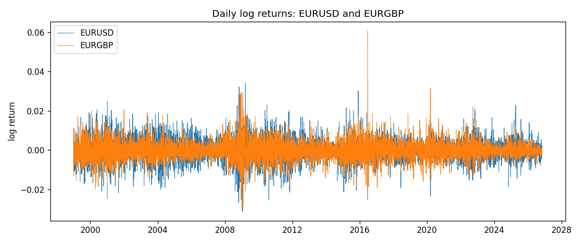
EWMA rho path with Pearson r reference
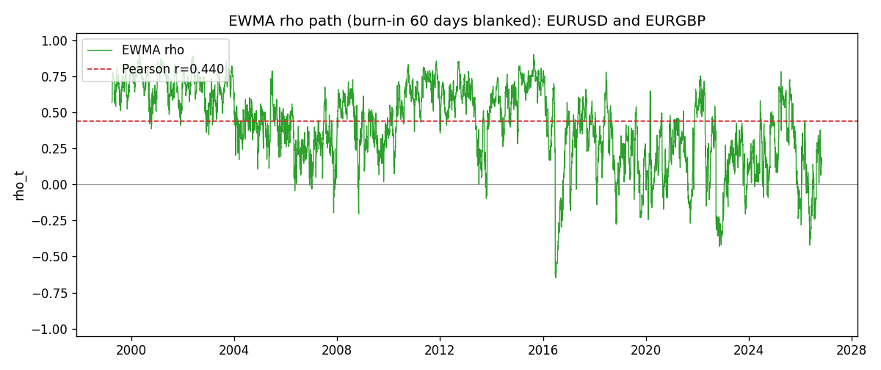

Data report
Every matched row that entered the EWMA recursion is stored in the sibling Excel workbook named EURUSD-EURGBP_EWMA_D1.xlsx. That file is the complete data archive for redrawing charts. Embedding all rows as a Word table is impractical at this length; the Word file holds the column list, column summaries, and the first and last 15 matched rows.
Columns: time, EURUSD_open, EURGBP_open, EURUSD_high, EURGBP_high, EURUSD_low, EURGBP_low, EURUSD_close, EURGBP_close, EURUSD_tick_volume, EURGBP_tick_volume, EURUSD_spread, EURGBP_spread, EURUSD_real_volume, EURGBP_real_volume, EURUSD_log_return, EURGBP_log_return, EURUSD_x_demeaned, EURGBP_y_demeaned, c_t, v_x, v_y, rho_t
Column summaries (matched calculation rows)
column | count | mean | std | min | 25% | 50% | 75% | max
EURUSD_open | 7183 | 1.1815763 | 0.15079461 | 0.8272 | 1.08621 | 1.16623 | 1.29409 | 1.5995
EURGBP_open | 7183 | 0.78698868 | 0.09663692 | 0.5734 | 0.6877 | 0.83389 | 0.86522 | 0.9769
EURUSD_high | 7183 | 1.1867072 | 0.15139096 | 0.8326 | 1.09029 | 1.17134 | 1.29941 | 1.6038
EURGBP_high | 7183 | 0.79006638 | 0.09701205 | 0.5789 | 0.6897 | 0.8369 | 0.8681 | 0.9799
EURUSD_low | 7183 | 1.1765677 | 0.15011491 | 0.8227 | 1.08209 | 1.16259 | 1.288515 | 1.5865
EURGBP_low | 7183 | 0.78428899 | 0.09645396 | 0.5682 | 0.6857 | 0.83166 | 0.86287 | 0.9661
EURUSD_close | 7183 | 1.1816163 | 0.15076829 | 0.8267 | 1.086135 | 1.16619 | 1.2941 | 1.5997
EURGBP_close | 7183 | 0.78703222 | 0.09663758 | 0.5735 | 0.6878 | 0.83395 | 0.86536 | 0.977
EURUSD_tick_volume | 7183 | 103246.15 | 173560.03 | 218 | 9420.5 | 52790 | 99596.5 | 1471626
EURGBP_tick_volume | 7183 | 87133.93 | 145499.42 | 154 | 6594.5 | 44358 | 81413 | 1424684
EURUSD_spread | 7183 | 19.326744 | 16.542159 | 0 | 8 | 12 | 20 | 50
EURGBP_spread | 7183 | 21.324655 | 19.119277 | 0 | 4 | 13 | 40 | 50
EURUSD_real_volume | 7183 | 4.0347326e+10 | 1.669497e+11 | 0 | 0 | 0 | 0 | 3.6149665e+12
EURGBP_real_volume | 7183 | 2.7872287e+10 | 1.3521454e+11 | 0 | 0 | 0 | 0 | 3.5726265e+12
EURUSD_log_return | 7183 | -5.81e-06 | 0.0057996 | -0.03123819 | -0.00324487 | 0 | 0.00325442 | 0.03433183
EURGBP_log_return | 7183 | 2.227e-05 | 0.00487305 | -0.03067367 | -0.00262314 | -9.879e-05 | 0.00256076 | 0.06075387
EURUSD_x_demeaned | 7183 | -0 | 0.0057996 | -0.03123237 | -0.00323906 | 5.81e-06 | 0.00326023 | 0.03433764
EURGBP_y_demeaned | 7183 | -0 | 0.00487305 | -0.03069594 | -0.00264541 | -0.00012106 | 0.00253849 | 0.0607316
c_t | 7183 | 1.243e-05 | 1.422e-05 | -8.97e-05 | 3.11e-06 | 8.81e-06 | 1.907e-05 | 0.00012799
v_x | 7183 | 3.361e-05 | 2.635e-05 | 3.69e-06 | 1.663e-05 | 2.742e-05 | 4.248e-05 | 0.00025675
v_y | 7183 | 2.374e-05 | 2.337e-05 | 1.89e-06 | 1.049e-05 | 1.823e-05 | 3.014e-05 | 0.00029342
rho_t | 7183 | 0.4094768 | 0.27482354 | -0.64566924 | 0.23269299 | 0.44437153 | 0.63372996 | 1
First 15 matched rows (selected columns)
time | EURUSD_close | EURGBP_close | EURUSD_log_return | EURGBP_log_return | EURUSD_x_demeaned | EURGBP_y_demeaned | c_t | v_x | v_y | rho_t
1999-01-06 | 1.1623 | 0.7019 | -0.011547966 | -0.013303338 | -0.011542155 | -0.013325607 | 9.2283735e-06 | 7.9932805e-06 | 1.0654309e-05 | 1
1999-01-07 | 1.1712 | 0.7097 | 0.0076280636 | 0.011051402 | 0.0076338749 | 0.011029132 | 1.3726372e-05 | 1.1010246e-05 | 1.7313556e-05 | 0.99417792
1999-01-08 | 1.1585 | 0.7062 | -0.010902799 | -0.004943862 | -0.010896988 | -0.0049661314 | 1.6149742e-05 | 1.7474292e-05 | 1.775449e-05 | 0.9168783
1999-01-11 | 1.1503 | 0.7053 | -0.007103287 | -0.0012752393 | -0.0070974756 | -0.0012975086 | 1.57333e-05 | 1.9448285e-05 | 1.6790233e-05 | 0.87066446
1999-01-12 | 1.1555 | 0.7077 | 0.0045103728 | 0.0033970309 | 0.0045161842 | 0.0033747615 | 1.5703765e-05 | 1.9505143e-05 | 1.6466159e-05 | 0.87626013
1999-01-13 | 1.1681 | 0.708 | 0.010845346 | 0.00042381861 | 0.010851158 | 0.00040154926 | 1.5022975e-05 | 2.5399692e-05 | 1.5487864e-05 | 0.75743603
1999-01-14 | 1.1681 | 0.7066 | 0 | -0.0019793588 | 5.8113555e-06 | -0.0020016281 | 1.4120899e-05 | 2.3875712e-05 | 1.4798983e-05 | 0.75122188
1999-01-15 | 1.1563 | 0.7012 | -0.010153245 | -0.0076715819 | -0.010147434 | -0.0076938512 | 1.7958015e-05 | 2.8621394e-05 | 1.7462765e-05 | 0.80326056
1999-01-18 | 1.1605 | 0.7017 | 0.0036256946 | 0.00071280921 | 0.0036315059 | 0.00069053986 | 1.7030997e-05 | 2.769538e-05 | 1.644361e-05 | 0.79806416
1999-01-19 | 1.1603 | 0.7007 | -0.00017235436 | -0.0014261269 | -0.00016654301 | -0.0014483962 | 1.602361e-05 | 2.6035322e-05 | 1.5582865e-05 | 0.79552758
1999-01-20 | 1.1566 | 0.7021 | -0.0031939256 | 0.0019960086 | -0.0031881143 | 0.0019737393 | 1.4684643e-05 | 2.5083047e-05 | 1.4881631e-05 | 0.76006017
1999-01-21 | 1.1601 | 0.7016 | 0.0030215416 | -0.00071240297 | 0.0030273529 | -0.00073467232 | 1.3670118e-05 | 2.4127956e-05 | 1.4021118e-05 | 0.7432256
1999-01-22 | 1.1587 | 0.7004 | -0.0012075213 | -0.0017118406 | -0.0012017099 | -0.00173411 | 1.2974944e-05 | 2.2766925e-05 | 1.3360279e-05 | 0.74395308
1999-01-25 | 1.1552 | 0.6966 | -0.0030251979 | -0.0054402425 | -0.0030193865 | -0.0054625118 | 1.3186054e-05 | 2.1947911e-05 | 1.4349005e-05 | 0.74303173
1999-01-26 | 1.1562 | 0.6962 | 0.00086527651 | -0.00057438255 | 0.00087108787 | -0.00059665191 | 1.2363706e-05 | 2.0676564e-05 | 1.3509424e-05 | 0.7397604
Last 15 matched rows (selected columns)
time | EURUSD_close | EURGBP_close | EURUSD_log_return | EURGBP_log_return | EURUSD_x_demeaned | EURGBP_y_demeaned | c_t | v_x | v_y | rho_t
2026-10-13 | 1.11965 | 0.84458 | 0.0037402957 | 0.00020130374 | 0.0037461071 | 0.00017903439 | 1.9623709e-06 | 1.0570438e-05 | 2.6756355e-06 | 0.36899554
2026-10-14 | 1.11545 | 0.84553 | -0.0037582255 | 0.0011241873 | -0.0037524142 | 0.0011019179 | 1.5965375e-06 | 1.0781049e-05 | 2.5879507e-06 | 0.30225299
2026-10-15 | 1.12172 | 0.84479 | 0.0056053107 | -0.00087557391 | 0.005611122 | -0.00089784326 | 1.1984707e-06 | 1.2023267e-05 | 2.481041e-06 | 0.21943162
2026-10-16 | 1.12371 | 0.84307 | 0.0017724895 | -0.0020380844 | 0.0017783008 | -0.0020603538 | 9.0672676e-07 | 1.1491613e-05 | 2.586882e-06 | 0.16630206
2026-10-19 | 1.12086 | 0.84259 | -0.0025394633 | -0.00056950988 | -0.0025336519 | -0.00059177923 | 9.4228491e-07 | 1.1187279e-05 | 2.4526813e-06 | 0.17988686
2026-10-20 | 1.12354 | 0.83957 | 0.0023881672 | -0.0035906254 | 0.0023939786 | -0.0036128948 | 3.6679625e-07 | 1.0859911e-05 | 3.0887009e-06 | 0.063332092
2026-10-21 | 1.12318 | 0.83839 | -0.00032046717 | -0.00140647 | -0.00031465582 | -0.0014287393 | 3.7176214e-07 | 1.0214256e-05 | 3.0258566e-06 | 0.066870968
2026-10-22 | 1.12139 | 0.83682 | -0.0015949606 | -0.0018743924 | -0.0015891493 | -0.0018966618 | 5.3030114e-07 | 9.7529248e-06 | 3.0601448e-06 | 0.097069799
2026-10-23 | 1.11989 | 0.83751 | -0.001338521 | 0.00082421033 | -0.0013327097 | 0.00080194098 | 4.343578e-07 | 9.2743162e-06 | 2.9151227e-06 | 0.083536881
2026-10-26 | 1.11735 | 0.83762 | -0.0022706559 | 0.00013133309 | -0.0022648445 | 0.00010906374 | 3.9347558e-07 | 9.0256285e-06 | 2.740929e-06 | 0.079109779
2026-10-27 | 1.11272 | 0.83595 | -0.004152342 | -0.0019957343 | -0.0041465306 | -0.0020180037 | 8.719299e-07 | 9.5157137e-06 | 2.8208136e-06 | 0.16829596
2026-10-28 | 1.1152 | 0.83651 | 0.0022262927 | 0.00066967224 | 0.0022321041 | 0.00064740289 | 9.0631834e-07 | 9.2437082e-06 | 2.6767126e-06 | 0.18220353
2026-10-29 | 1.11772 | 0.83553 | 0.0022571351 | -0.0011722209 | 0.0022629465 | -0.0011944902 | 6.8975519e-07 | 8.9963413e-06 | 2.6017183e-06 | 0.14257122
2026-10-30 | 1.11644 | 0.83351 | -0.0011458446 | -0.0024205543 | -0.0011400333 | -0.0024428237 | 8.154639e-07 | 8.5345414e-06 | 2.8036584e-06 | 0.16670633
2026-11-02 | 1.11881 | 0.83426 | 0.002120569 | 0.00089940465 | 0.0021263803 | 0.0008771353 | 8.7844346e-07 | 8.2937585e-06 | 2.6816009e-06 | 0.1862692

